**EXCEL QUESTIONS**

Register Number: 1740256

**Date:** 26/09/2017

--------------------------------------------------------------------------------------------

**Question 1**

What is data analysis pack in Excel? Examine any three options in data analysis pack.

**ANS** Data analysis tool pack in excel is a tool in Microsoft Excel that used to perform different operations of statistics on any given data. The tool pack does not come activated usually when it is downloaded, therefore the user has to activate it in options of excel and click on add – ons after which it can be accessible.

The options we can perform on data analysis tool pack are such as descriptive statistics, making a histogram and even calculating regression!

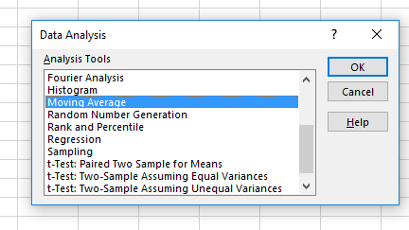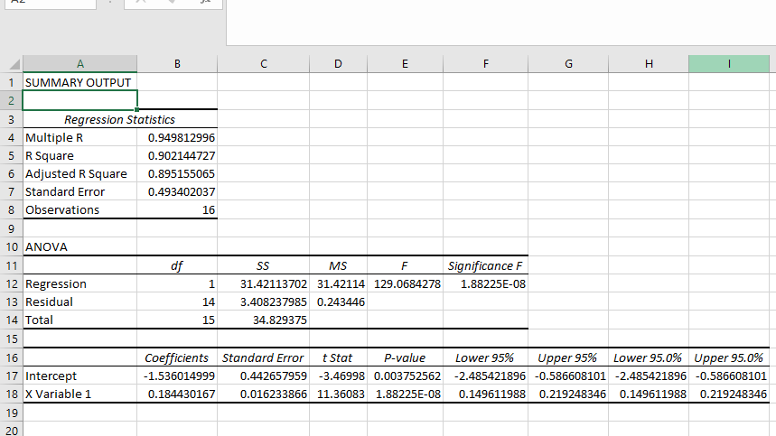

The above pictures show the use of many operations with the data analysis tool pack.

**Question 2**

What are the different ways of finding average in EXCEL? Also explain any four functions which can be used in EXCEL.

**ANS** the different ways of finding average in Excel are by –

Using the equal to average function by selecting the data in the excel sheet i.e. finding the arithmetic mean.

The 4 different functions which can be used are

1. **Sorting–** The data given can be sorted either numerically or alphabetically in different ways.
2. **Graphical representation** – This data can be filtered and made into different graphs.
3. **Correlation** – Correlation can also be analyzed between 2 data sets.
4. **Statistical functions** – The mean, median and mode can be found from the data set.

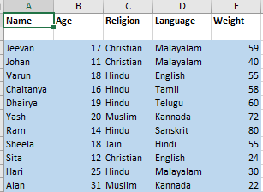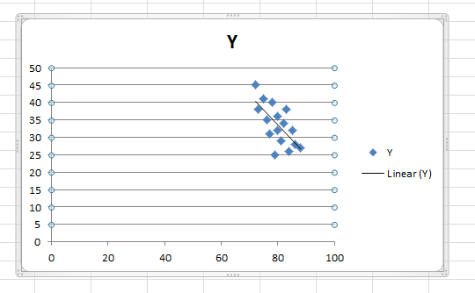

The above pictures show data being sorted, correlation being made and also the graphical representation of some data.

**--------------------------------------------------------------------------------------------------------------------------------------**

**Question 3**

Explain “Pivot table” and its uses. Give the steps to construct it in EXCEL by giving suitable example.

**ANS** A pivot table is a data summarization tool used in Excel. You can use a pivot table to summarize data that you've added to a table.   A table may be too large to allow you to analyze certain parts. A pivot table allows you to basically extract those parts (while leaving them in the table) to come up with figures, view the data, etc.

1. Select the given data and go insert menu.
2. Choose the pivot table option making sure that the input range contains the entire data set.
3. A pivot table is then formed.

|  |  |
| --- | --- |
| **Row Labels** | **Count of health** |
| **1** |  |
| 1 | 19 |
| 2 | 37 |
| 3 | 45 |
| **1 Total** | **101** |
| **Grand Total** | **101** |

The above diagram shows a pivot table for health status of males and females for a certain data set.

**--------------------------------------------------------------------------------------------------------------------------------------**

**Question 4**

Explain the procedure of plotting histogram and frequency curve using EXCEL when raw data is given.

**ANS** To plot a frequency curve -

1. Enter the data into excel and go to insert.
2. Choose the data column and the corresponding frequency column and go to insert and choose line chart under the chart tag.

To plot a histogram-

1. Enter the data into excel and click on data analysis tool pack.
2. Choose the histogram button.
3. Select the data as input range and the corresponding frequency as the bin range with a tick mark on chart and click on okay after which a histogram appears.

**--------------------------------------------------------------------------------------------------------------------------------------**

**Question 5**

Write the steps for “FORMATTING” in EXCEL.

**ANS** In Microsoft Office Excel, formatting worksheet (or sheet) data is easier than ever. You can use several fast and simple ways to create professional-looking worksheets that display your data effectively.

The steps are -

## Copying an existing format to other data

## Using styles to quickly format data

## Working with document themes

## Formatting data manually

## Using borders and colors to emphasize data

------------------------------------------------------------------------------------------------------------

THE END

--------------------------------------------------------------------------------------------